VISALIA TECHNICAL EARLY COLLEGE

***HOME OF THE WOLVERINES***



**Daily Bulletin - Volume 12; Issue 1**

**THURSDAY, AUGUST 10, 2023**

**Welcome Back Staff and Students**

**Bell Schedule for August 10th and August 11th**

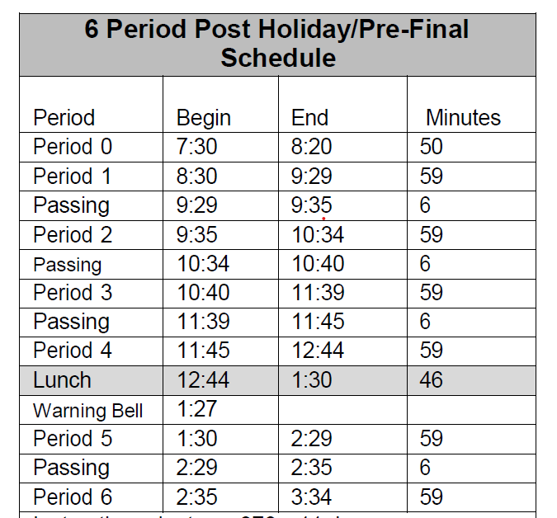

**Ice Breaker Dance –** Friday, August 25th from 6pm-8pm in the Multipurpose Room.

**SCICON Counselors –**SCICON Counselors needs for **August 22-25, January 8-12th, May 6-10th.** Pick up an Application in the front office. Open to Juniors and Seniors only. See Mrs. Lalanne or Mrs. Roebuck with any questions.

**Picture Make-Ups –** Wednesday, October 18th. More information to follow.

**Students** – Friendly reminder that the front parking lot is for staff and visitors only. There is student parking in the lot north of the office. Thank you –

**Third party food deliveries** will NOT be accepted in the office (parent lunch drop-off ok). Students must meet third party deliveries during lunch only in front of the school. Any deliveries before or after lunch will not be accepted. Thank you –

**Students Late From Lunch –** If you are tardy returning to school following lunch, your ID will be taken and you will lose your off campus lunch privileges for 5 days.

**Students late on Friday –** If students are late to school on Friday, they will be assigned lunch detention.