VISALIA TECHNICAL EARLY COLLEGE

***HOME OF THE WOLVERINES***



**Daily Bulletin - Volume 12; Issue 82**

**MONDAY, DECEMBER 11, 2023**

**Finals–December 13th, 14th and 15th – Schedule is Below**

**Winter Break – December 18 – January 5th**

**School Resumes Monday, January 8, 2024**

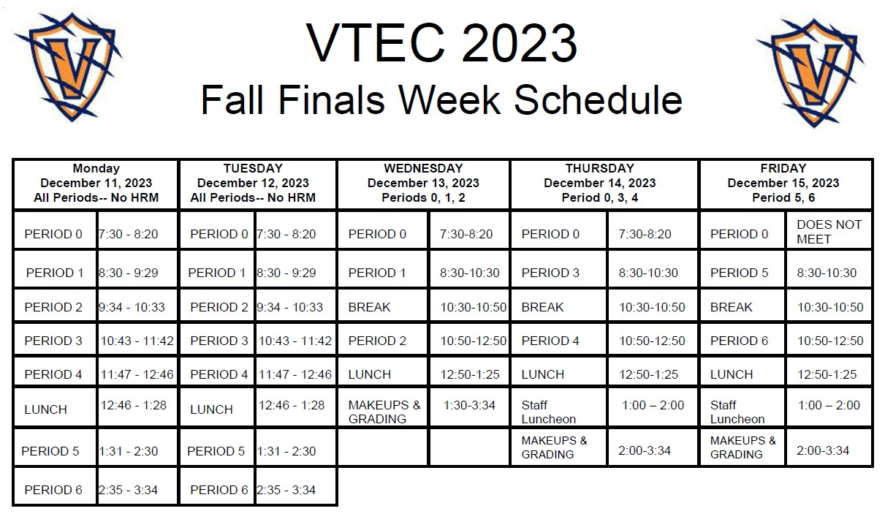

**Lost and Found** – Lost and Found items are located outside the office. Any items not claimed by Friday, December 15th will be thrown away. Thank you!

Calling all VTEC students! The **CSF Toy Drive** is going on NOW until December 15th. Please bring any new unwrapped toys to your homeroom class. For every two items, you will receive one hour of community service. See Mrs. Gonzalez for any questions. Donate today!

**Senior Parents –** FAFSA opens December 31st. See Mrs. Lalanne if you have any questions.

**Yearbooks and Senior pages** are for sale in the finance office. Forms are in the office.

**Seniors –**Per Board Policy you must have an **Attendance Percentage of at least 94%** to participate in Senior Activities. Not sure what your attendance percentage is? Ask Mrs. Roebuck or Mrs. Diaz.

**SCICON Counselors –**SCICON Counselors needed for **May 6-10.** Pick up an Application in the front office. Open to Juniors and Seniors only. See Mrs. Lalanne or Mrs. Roebuck with any questions.

**Students** – Friendly reminder that the front parking lot is for staff and visitors only. There is student parking in the lot north of the office. Thank you –

**Students Late From Lunch –** If you are tardy returning to school following lunch, your ID will be taken and you will lose your off campus lunch privileges for 5 days.

**Students late on Friday –** If students are late to school on Friday, they will be assigned lunch detention.

**Attention 10th – 12th grade students:** You will not be allowed to leave campus if you have any of the following grade combinations.  We are only using PowerSchool as an indicator of your grades and the list will be updated every two weeks.

* Two or more Fs
* One F and any Ds
* 3 Ds

**FFA Calendar of Events is attached**. Please see your Ag Teacher or the front office with any questions.

**Scholarship Foundation Meetings –** All Parents are welcome to attend!

February 1st at 6pm

March 7th at 6pm

April 4th at 6pm

May 2nd at 6pm