VISALIA TECHNICAL EARLY COLLEGE

***HOME OF THE WOLVERINES***



**Daily Bulletin - Volume 12; Issue 92**

**TUESDAY, JANUARY 16, 2024**

**Tuesday, January 16th Bell Schedule – All 6 Periods – No Homeroom**

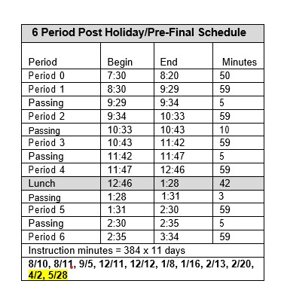

**SOPHOMORES ONLY –** The last day to sign for Drivers Ed is Tuesday, January 16th. Sign up in the office. Any questions – see the office.

**FAFSA Workshop –**Wednesday, January 24th at 6pm in Room 4. Parents and students invited.

**FFA Spring Schedule of Events –** The schedule of FFA events for the Spring Semester is attached. If you have any questions, please reach out to your Ag Teacher.

**Yearbooks and Senior pages** are for sale in the finance office. Forms are in the office.

**Seniors –**Per Board Policy you must have an **Attendance Percentage of at least 94%** to participate in Senior Activities. Not sure what your attendance percentage is? Ask Mrs. Roebuck or Mrs. Diaz.

**SCICON Counselors –**SCICON Counselors needed for **May 6-10.** Pick up an Application in the front office. Open to Juniors and Seniors only. See Mrs. Lalanne or Mrs. Roebuck with any questions.

**Students** – Friendly reminder that the front parking lot is for staff and visitors only. There is student parking in the lot north of the office. Thank you –

**Students Late From Lunch –** If you are tardy returning to school following lunch, your ID will be taken and you will lose your off campus lunch privileges for 5 days.

**Students late on Friday –** If students are late to school on Friday, they will be assigned lunch detention.

**Attention 10th – 12th grade students:** You will not be allowed to leave campus if you have any of the following grade combinations.  We are only using PowerSchool as an indicator of your grades and the list will be updated every two weeks.

* Two or more Fs
* One F and any Ds
* 3 Ds

**Scholarship Foundation Meetings –** All Parents are welcome to attend!

February 1st at 6pm

March 7th at 6pm

April 4th at 6pm

May 2nd at 6pm