VISALIA TECHNICAL EARLY COLLEGE

***HOME OF THE WOLVERINES***



**Daily Bulletin - Volume 12; Issue 138**

**FRIDAY, MARCH 22, 2024**

**Spring Break – March 25-April 1st**

**Students Return to School on Tuesday, April 2nd**

**Spring Break – Students Return on Tuesday, April 2nd – Bell Schedule As Follows:**

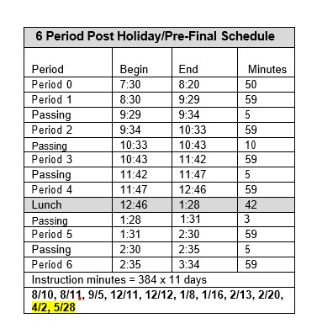

**Free Prom Dress Program – The Enchanted Evening Prom Dress program will be held on April 13th at the Wyndom Hotel. Sign up in the office before April 10th! Students must be a Junior or Senior only.**

**COS Tutorial Services** available – see attached flyer.

**ASB Pizza Sales During Lunch** – Students – ASB will be selling pizza during lunch on Wednesdays and Fridays for $2.00/slice. Cash only.

**FFA Spring Schedule of Events –** The schedule of FFA events for the Spring Semester is attached. If you have any questions, please reach out to your Ag Teacher.

**Seniors –**Per Board Policy you must have an **Attendance Percentage of at least 94%** to participate in Senior Activities. Not sure what your attendance percentage is? Ask Mrs. Roebuck or Mrs. Diaz.

**SCICON Counselors –**SCICON Counselors needed for **May 6-10.** Pick up an Application in the front office. Open to Juniors and Seniors only. See Mrs. Lalanne or Mrs. Roebuck with any questions.

**Students** – Friendly reminder that the front parking lot is for staff and visitors only. There is student parking in the lot north of the office. Thank you –

**Students Late From Lunch –** If you are tardy returning to school following lunch, your ID will be taken and you will lose your off campus lunch privileges for 5 days.

**Students late on Friday –** If students are late to school on Friday, they will be assigned lunch detention.

**Attention 10th – 12th grade students:** You will not be allowed to leave campus if you have any of the following grade combinations.  We are only using PowerSchool as an indicator of your grades and the list will be updated every two weeks.

* Two or more Fs
* One F and any Ds
* 3 Ds

**Scholarship Foundation Meetings –** All Parents are welcome to attend!

April 4th at 6pm

May 2nd at 6pm