VISALIA TECHNICAL EARLY COLLEGE

***HOME OF THE WOLVERINES***



**Daily Bulletin - Volume 12; Issue 178**

**TUESDAY, MAY 28, 2024**

**Bell Schedule for Tuesday, May 28th – All 6 Periods**

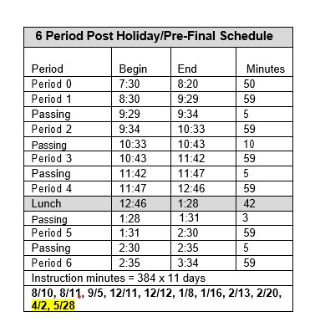

**Upcoming Important Dates -**

**May 29th – Senior Sunset @ 7pm**

**May 29-May 31 – Finals (SEE ATTACHED BELL SCHEDULE)**

**May 30th – Graduation – 4pm - LJ Williams Theater (Graduation practice @ 8am)**

**May 31 – Last Day of School**

**Spring Finals Schedule – Attached – See Below**

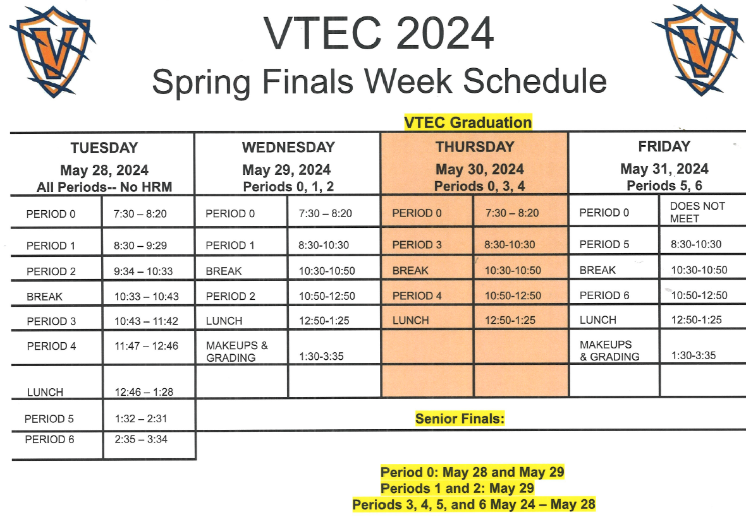

**Students – Mark Your Calendars!** Round Up will be Thursday, August 8th – See attached flyer!

**Students and Staff –** Yearbooks are still available and for sale. Cost is $65. See Mr. Cumiford in Room 5 or stop by the office.

**Seniors –** You need to turn in your **Request for Transcript** form to Mrs. Roebuck prior to June 15th. You can pick up the form in the office. See Mrs. Roebuck if you have any questions.

**Parents and Students –** As the weather begins to warm up, please follow the VUSD dress code guidelines. Parents, we appreciate your help in enforcing the dress code. Please reach out if you have any questions.

**Seniors –**Per Board Policy you must have an **Attendance Percentage of at least 94%** to participate in Senior Activities. Not sure what your attendance percentage is? Ask Mrs. Roebuck or Mrs. Diaz.

**Students** – Friendly reminder that the front parking lot is for staff and visitors only. There is student parking in the lot north of the office. Thank you –

**Students Late From Lunch –** If you are tardy returning to school following lunch, your ID will be taken and you will lose your off campus lunch privileges for 5 days.

**Students late on Friday –** If students are late to school on Friday, they will be assigned lunch detention.