VISALIA TECHNICAL EARLY COLLEGE

***HOME OF THE WOLVERINES***



**Daily Bulletin - Volume 12; Issue 180**

**FRIDAY, MAY 31, 2024**

**Upcoming Important Dates -**

**Thursday, August 8th – Round Up**

**Thursday, August 15th – First Day of School**

**Bell Schedule – FRIDAY, MAY 31st - **NO LATE START\*\***

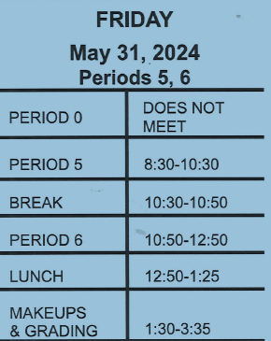

**Spring Finals Schedule – Attached – See Below**

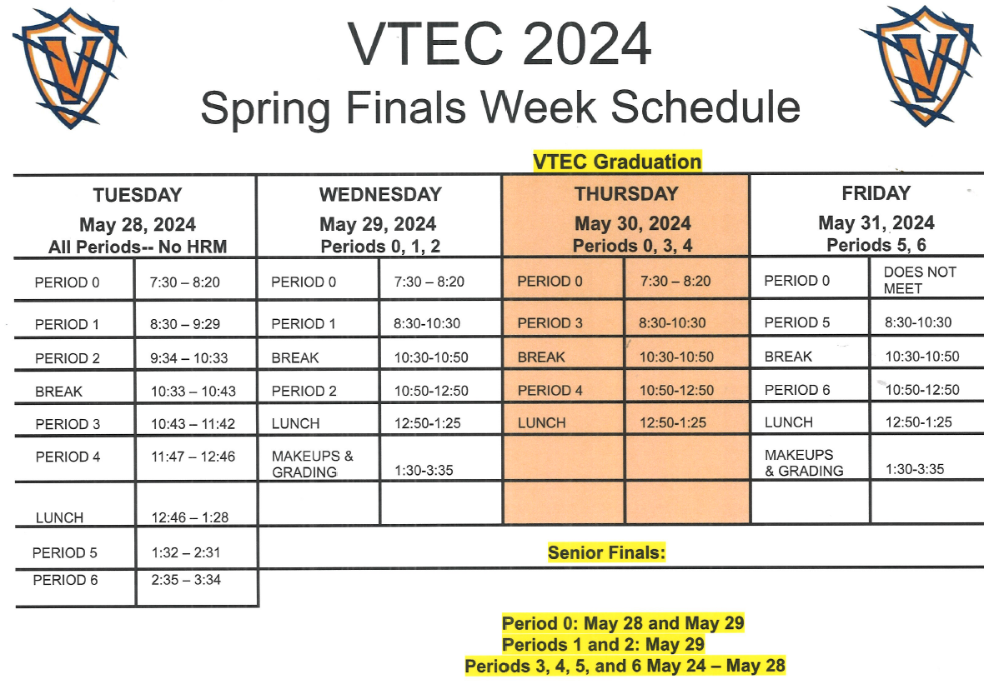

**Students – Mark Your Calendars!** Round Up will be Thursday, August 8th – See attached flyer!

**Students and Staff –** Yearbooks are still available and for sale. Cost is $65. See Mr. Cumiford in Room 5 or stop by the office.

**Parents and Students –** As the weather begins to warm up, please follow the VUSD dress code guidelines. Parents, we appreciate your help in enforcing the dress code. Please reach out if you have any questions.

**Students** – Friendly reminder that the front parking lot is for staff and visitors only. There is student parking in the lot north of the office. Thank you –

**Students Late From Lunch –** If you are tardy returning to school following lunch, your ID will be taken and you will lose your off campus lunch privileges for 5 days.

**Students late on Friday –** If students are late to school on Friday, they will be assigned lunch detention.