VISALIA TECHNICAL EARLY COLLEGE

***HOME OF THE WOLVERINES***



**Daily Bulletin - Volume 13; Issue 4**

**TUESDAY, AUGUST 20, 2024**

**Students and Staff – Welcome Back!**

**Back to School Night – Monday, August 26th -**

**Bell Schedule for Tuesday, Wednesday and Thursday -**

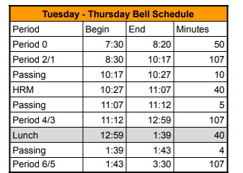

**Seniors** – Senior Cap-n-Gown meeting will be Tuesday, October 29th during Homeroom!

**Students** – Ice Breaker Dance – Friday, August 30th.

**Students –**Juniors and Seniors interested in SCICON – pick up an Application in the office. We have two dates available. January 21-24th with Valley Life Charter and March 31-April 4 with Charter Home School. See Mrs. Lalanne or Mrs. Roebuck if you have questions.

**Students –**Yearbooks for sale in the office. $55 until January, 2025. Forms are available in the office.

**Students, Parents and Staff –** Check out the Calendar on the VTEC website! You can see all of the VTEC activities on the Calendar. Reach out if you have questions.

**Students** – Friendly reminder that the front parking lot is for staff and visitors only. There is student parking in the lot north of the office. Thank you –