VISALIA TECHNICAL EARLY COLLEGE

***HOME OF THE WOLVERINES***



**Daily Bulletin - Volume 13; Issue 13**

**TUESDAY, SEPTEMBER 3, 2024**

**Bell Schedule for Tuesday, September 3rd –**

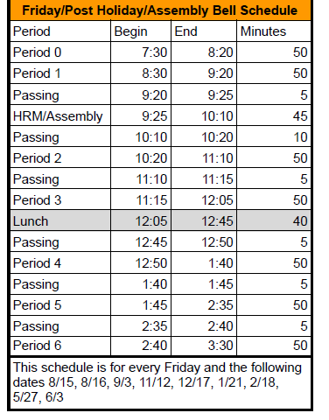

**FFA Meeting –** September 4th - 4:45pm at VTEC.

**TCOE College Night** – Tuesday, September 10th.

**Staff Development Day** – Monday, September 16th – Students released at 1pm.

**Picture Re-Takes –**Picture re-takes will be held on Thursday, September 19th.

**Senior Parent Night Meeting** – Wednesday, September 25th from 6pm-7pm.

**Harvest Dance** – Saturday, September 28th from 8pm-11pm.

**Seniors** – Senior Cap-n-Gown meeting will be Tuesday, October 29th during Homeroom!

**Students –**Juniors and Seniors interested in SCICON – pick up an Application in the office. We have two dates available. January 21-24th with Valley Life Charter and March 31-April 4 with Charter Home School. See Mrs. Lalanne or Mrs. Roebuck if you have questions.

**Students –**Yearbooks for sale in the office. Cost is $55. Forms are available in the office.

**Students, Parents and Staff –** Check out the Calendar on the VTEC website! You can see all of the VTEC activities on the Calendar. Reach out if you have questions.

**FFA Calendar of Events –** The 2024/2025 FFA Calendar of Events is attached.

**Students** – Friendly reminder that the front parking lot is for staff and visitors only. There is student parking in the lot north of the office. Thank you –

**Students** – If you have **3 tardies**, you will lose off campus lunch privileges for 3 days.

If you have **6 or more tardies**, you will lose off campus lunch privileges for 5 days and have lunch detention in Room 4 for the first 20 minutes of lunch.

If you are **late coming back from lunch**, you will lose off campus privileges for 5 days.