VISALIA TECHNICAL EARLY COLLEGE

***HOME OF THE WOLVERINES***



**Daily Bulletin - Volume 13; Issue 36**

**FRIDAY, OCTOBER 4, 2024**

**FALL BREAK – No School October 14th and October 15th**

**Staff Development Day – Monday, October 21st –**

**Students Released at 1pm**

**Friday, October 4th – Extended Lunch – See Bell Schedule Below**

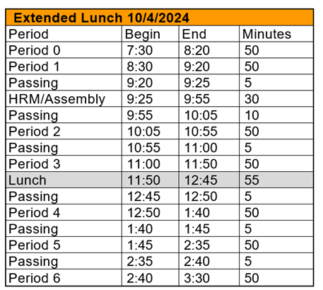

**Pancake Breakfast Tickets** are for sale in the office. Tickets are $5. The festival will be held at VTEC on Saturday, October 5th from 8am-11am.

**Students** - Harvest Fest is this week and our ASB dress-up days are:

Friday - Dress to Impress

**Students** - We have an Extended Lunch this Friday, October 4th! Vendors selling will be Tony’s Pizza, Javi’s Tacos, The Sweet Stand Mini Pancakes, and ShareTea. Bring cash, only some vendors accept cards.

**Students -** Voting for Harvest King, Queen, Prince, and Princess will start on Friday, October 4 from 8:00am to the first 10 minutes of Homeroom. Announcements of Harvest King, Queen, Prince, and Princess will also be during Homeroom. All Homeroom classes will go to the arbor to see who wins.

**Students -** Esports Club meets every Tuesday after school until 4:30pm in Mrs. Ramirez class, Room 8. Student and Parent contract needs to be signed to join and participate.

**Students -** Bible Club meets every Tuesday and Thursday at lunch in Mrs. Foll's room - Room 14. Come join us - open to all!

**Students** - Pizza Sales: Every Friday Pizza will be sold for $2 outside Room 8, drinks will also be sold.

**Seniors** – Senior Cap-n-Gown meeting will be Tuesday, October 29th during Homeroom!

**Students –**Juniors and Seniors interested in SCICON – pick up an Application in the office. We have two dates available. January 21-24th with Valley Life Charter and March 31-April 4 with Charter Home School. See Mrs. Lalanne or Mrs. Roebuck if you have questions.

**Students –**Yearbooks for sale in the office. Cost is $55. Forms are available in the office.

**Students, Parents and Staff –** Check out the Calendar on the VTEC website! You can see all of the VTEC activities on the Calendar. Reach out if you have questions.

**FFA Calendar of Events –** The 2024/2025 FFA Calendar of Events is attached.

**Students** – Friendly reminder that the front parking lot is for staff and visitors only. There is student parking in the lot north of the office. Thank you –

**Students** – If you have **3 tardies**, you will lose off campus lunch privileges for 3 days.

If you have **6 or more tardies**, you will lose off campus lunch privileges for 5 days and have lunch detention in Room 4 for the first 20 minutes of lunch.

If you are **late coming back from lunch**, you will lose off campus privileges for 5 days.