VISALIA TECHNICAL EARLY COLLEGE
HOME OF THE WOLVERINES



Daily Bulletin - Volume 14; Issue 2
FRIDAY, AUGUST 15, 2025

Welcome Back Students and Staff!!

Bell Schedule –Friday, August 15th

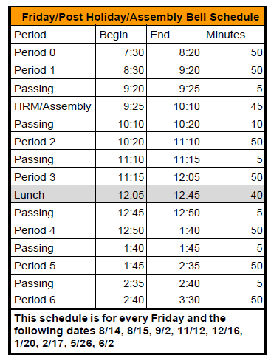

Back to School Night – Monday, August 25th. More Information to follow.

Icebreaker Dance – Friday, August 29th – More information to follow.

Picture Re-Takes – Thursday, September 18th.

COS Summer School Textbook Reimbursements – If you took a COS Summer School course and need to submit a reimbursement for your textbook, please complete the form, attach a copy of your receipt and a copy of your final grade. Reimbursements need to be turned in prior to AUGUST 30TH. Please see the office if you have any questions.

Yearbooks for Sale – Yearbooks are for sale. Order forms are available in the office. Price is $60 until January at which time the price will go up.

Students – If your third party food delivery is delivered after the lunch bell rings – you may pick up your food after school. Food will not be available during class time.

Parents/Students - If your student has an unscheduled/COS period and chooses to remain on campus they must report to Room 4 and stay in the room for the duration of the period. Due to safety, staff must know where students are at all times while on campus. Students who have an unscheduled/COS class during their schedule may leave campus but must check out through the front office. Thank you for your understanding.

Students – Friendly reminder that the front parking lot is for staff and visitors only. There is student parking in the lot north of the office. Thank you –

Students – If you have 3 tardies, you will lose off campus lunch privileges for 3 days.
If you have 6 or more tardies, you will lose off campus lunch privileges for 5 days and have lunch detention in Room 4 for the first 20 minutes of lunch.

Students – If you have any of the following – you will NOT be able to leave campus for lunch:
- Two or more F’s
- One F and any D’s
- 3+ D’s

If you are late coming back from lunch, you will lose off campus privileges for 5 days.

