VISALIA TECHNICAL EARLY COLLEGE
HOME OF THE WOLVERINES



Daily Bulletin - Volume 14; Issue 89
TUESDAY, JANUARY 20, 2026

**Staff Development Day Monday, January 26th –
Students Released at 2pm**

Bell Schedule – Tuesday, January 20th
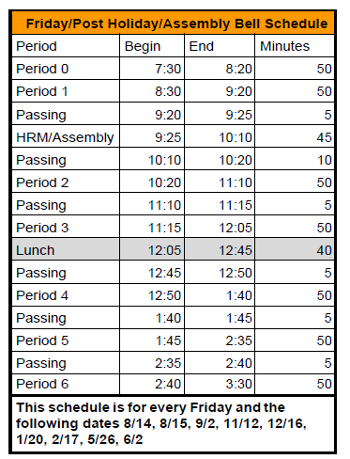

Students – Textbook reimbursement forms are due NO later than January 23rd. You need to complete and turn in textbook reimbursement form, provide the receipt and provide a copy of your COS grade. Turn the completed forms into the office. Any questions, see Mrs. Roebuck.

VTEC and Cane’s Fundraiser – February 10th at the Visalia Cane’s on Mooney. See attached flyer.

Ag Boosters Club Meeting – Thursday, February 5th at 5pm in Room 4. All are welcome. See attached flyers.

Seniors – Grad Nite is May 20, 2026. See attached flyer. Cost is $360. Total payment due by February 27, 2026.

2025-2026 FFA Schedule of Events is attached.

FAFSA Workshop – January 29th at 5pm in Room 4.

Yearbooks for Sale – Yearbooks are for sale. Order forms are available in the office. Price is $60 until January at which time the price will go up.

Students – If your third party food delivery is delivered after the lunch bell rings – you may pick up your food after school. Food will not be available during class time.

Parents/Students - If your student has an unscheduled/COS period and chooses to remain on campus they must report to Room 4 and stay in the room for the duration of the period. Due to safety, staff must know where students are at all times while on campus. Students who have an unscheduled/COS class during their schedule may leave campus but must check out through the front office. Thank you for your understanding.

Students – Friendly reminder that the front parking lot is for staff and visitors only. There is student parking in the lot north of the office. Thank you –

Students – If you have 3 tardies, you will lose off campus lunch privileges for 3 days.
If you have 6 or more tardies, you will lose off campus lunch privileges for 5 days and have lunch detention in Room 4 for the first 20 minutes of lunch.

Students – If you have any of the following – you will NOT be able to leave campus for lunch:
- Two or more F’s
- One F and any D’s
- 3+ D’s

If you are late coming back from lunch, you will lose off campus privileges for 5 days.

