VISALIA TECHNICAL EARLY COLLEGE
HOME OF THE WOLVERINES



Daily Bulletin - Volume 14; Issue 107
FRIDAY, FEBRUARY 13, 2026

No School – Monday, February 16th
President’s Day

Tuesday, February 17th Bell Schedule – All 6 Periods

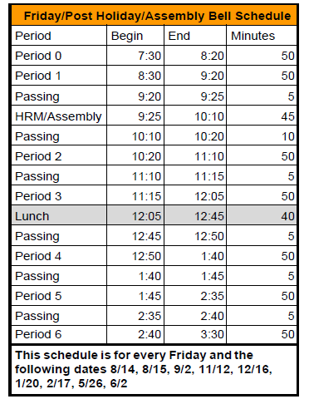

Denim & Diamond Tickets are for sale in the office! $80 per person. Cash or check only please. The event is Saturday, March 7th.

Seniors – It is Scholarship Season! Attached please find the VTEC Scholarship Foundation Scholarship (due March 13th by 3pm) and the VTEC General Scholarship (due Friday, February 13th). Also attached is a brag sheet which is helpful when asking staff members for a letter of recommendation.

Seniors – FAFSA Workshop Thursday, February 19th @5pm. See Mrs. Lalanne for more information.

Seniors – Cap-n-Gown photo for the yearbook Monday, February 23rd at 8am in Room 4.
Seniors – Grad Nite is May 20, 2026. See attached flyer. Cost is $360. Total payment due by February 27, 2026.

2025-2026 FFA Schedule of Events is attached.

Yearbooks for Sale – Yearbooks are for sale. Order forms are available in the office. Price is $65 until April.

Students – If your third party food delivery is delivered after the lunch bell rings – you may pick up your food after school. Food will not be available during class time.

Parents/Students - If your student has an unscheduled/COS period and chooses to remain on campus they must report to Room 4 and stay in the room for the duration of the period. Due to safety, staff must know where students are at all times while on campus. Students who have an unscheduled/COS class during their schedule may leave campus but must check out through the front office. Thank you for your understanding.

Students – Friendly reminder that the front parking lot is for staff and visitors only. There is student parking in the lot north of the office. Thank you –

Students – If you have 3 tardies, you will lose off campus lunch privileges for 3 days.
If you have 6 or more tardies, you will lose off campus lunch privileges for 5 days and have lunch detention in Room 4 for the first 20 minutes of lunch.

Students – If you have any of the following – you will NOT be able to leave campus for lunch:
- Two or more F’s
- One F and any D’s
- 3+ D’s

If you are late coming back from lunch, you will lose off campus privileges for 5 days.

