VISALIA TECHNICAL EARLY COLLEGE
HOME OF THE WOLVERINES



Daily Bulletin - Volume 14; Issue 126
FRIDAY, MARCH 13, 2026

Staff Development Day – Monday, March 16th – Students Released at 2pm

VTEC Open House – Tuesday, March 17th – More Info To Follow

Spring Break – March 30th- April 3rd

Bell Schedule – Monday, March 16th – Students Released at 2pm

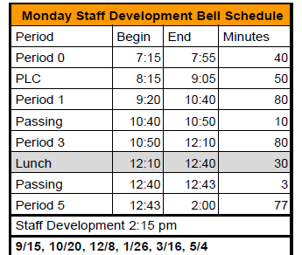

Seniors – The VTEC Scholarship Foundation Scholarship is due March 13th by 3pm – (no late applications will be accepted). See Mrs. Lalanne if you have any questions.

Enchanted Evening Prom Dress Give-away – Saturday, March 28th from 6am-1pm. Signs ups are in the office with Mrs. Roebuck. Available to Juniors and Seniors only. You must sign up by March 25th.
The Glow and Roll at Roller Towne is Saturday, March 14th. Prices are $10 with ASB; $15 without ASB; and $20 at the door. Tickets will be on sale beginning Monday in the Finance Office from 1pm-4pm. Cash or check only.

After School Cooking Class – Mondays and Wednesdays from 3:40pm-5pm in the VTEC Student Store/Farmhouse.

2025-2026 FFA Schedule of Events is attached.

Yearbooks for Sale – Yearbooks are for sale. Order forms are available in the office. Price is $65 until April.

Students – If your third party food delivery is delivered after the lunch bell rings – you may pick up your food after school. Food will not be available during class time.

Parents/Students - If your student has an unscheduled/COS period and chooses to remain on campus they must report to Room 4 and stay in the room for the duration of the period. Due to safety, staff must know where students are at all times while on campus. Students who have an unscheduled/COS class during their schedule may leave campus but must check out through the front office. Thank you for your understanding.

Students – Friendly reminder that the front parking lot is for staff and visitors only. There is student parking in the lot north of the office. Thank you –

Students – If you have 3 tardies, you will lose off campus lunch privileges for 3 days.
If you have 6 or more tardies, you will lose off campus lunch privileges for 5 days and have lunch detention in Room 4 for the first 20 minutes of lunch.

Students – If you have any of the following – you will NOT be able to leave campus for lunch:
- Two or more F’s
- One F and any D’s
- 3+ D’s

If you are late coming back from lunch, you will lose off-campus privileges for 5 days.

