VISALIA TECHNICAL EARLY COLLEGE
HOME OF THE WOLVERINES



Daily Bulletin - Volume 14; Issue 157
MONDAY, MAY 4, 2026

Monday, May 4th – Staff Development Day
Students Released at 2pm

Bell Schedule for Monday, May 4th – Students Released at 2pm

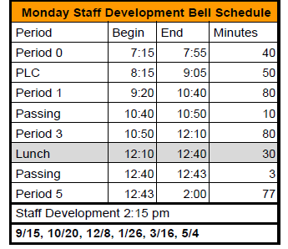

Parents – The 2026/2027 Emergency Card/Registration portal is currently open. Please complete the documentation before the end of the school year. Please reach out to the office if you have any questions. This information is required of ALL parents.

Class of 2026 Graduation – Thursday, June 4th at 4pm at the LJ Williams Theater.

Prom Tickets are for sale in the Finance Office -Tickets can be purchased between 1pm-4pm in the Finance Office, cash or check only. Prices are $60 w/ASB; $70 w/o ASB and $100 at the door. Prom is May 9th from 8pm-11pm at the Visalia Convention Center.

Seniors – Your Request for Transcript form has been posted in Schoology. Please complete this form. It is required prior to graduation. This form is necessary so that the office can mail your official transcript to the college you will be attending. Reach out to Mrs. Roebuck if you have any questions.

Scholarship Foundation Meeting – May 20th at 5:30pm – all are welcome!

Afterschool Real Estate Class – Mondays and Wednesdays from 3:40pm-5pm in Room 16.

2025-2026 FFA Schedule of Events is attached.

Yearbooks for Sale – Yearbooks are for sale. Order forms are available in the office.
Price is $70.

Students – If your third party food delivery is delivered after the lunch bell rings – you may pick up your food after school. Food will not be available during class time.

Parents/Students - If your student has an unscheduled/COS period and chooses to remain on campus they must report to Room 4 and stay in the room for the duration of the period. Due to safety, staff must know where students are at all times while on campus. Students who have an unscheduled/COS class during their schedule may leave campus but must check out through the front office. Thank you for your understanding.

Students – Friendly reminder that the front parking lot is for staff and visitors only. There is student parking in the lot north of the office. Thank you –

Students – If you have 3 tardies, you will lose off campus lunch privileges for 3 days.
If you have 6 or more tardies, you will lose off campus lunch privileges for 5 days and have lunch detention in Room 4 for the first 20 minutes of lunch.

Students – If you have any of the following – you will NOT be able to leave campus for lunch:
- Two or more F’s
- One F and any D’s
- 3+ D’s

If you are late coming back from lunch, you will lose off-campus privileges for 5 days.

