VISALIA TECHNICAL EARLY COLLEGE
HOME OF THE WOLVERINES



Daily Bulletin - Volume 14; Issue 171
TUESDAY, MAY 26, 2026

FINALS Bell Schedule – June 1st-5th
See Bell Schedule Below

Bell Schedule – Tuesday, May 26th –

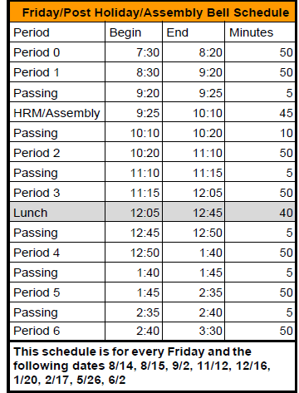

FINALS Bell Schedule –

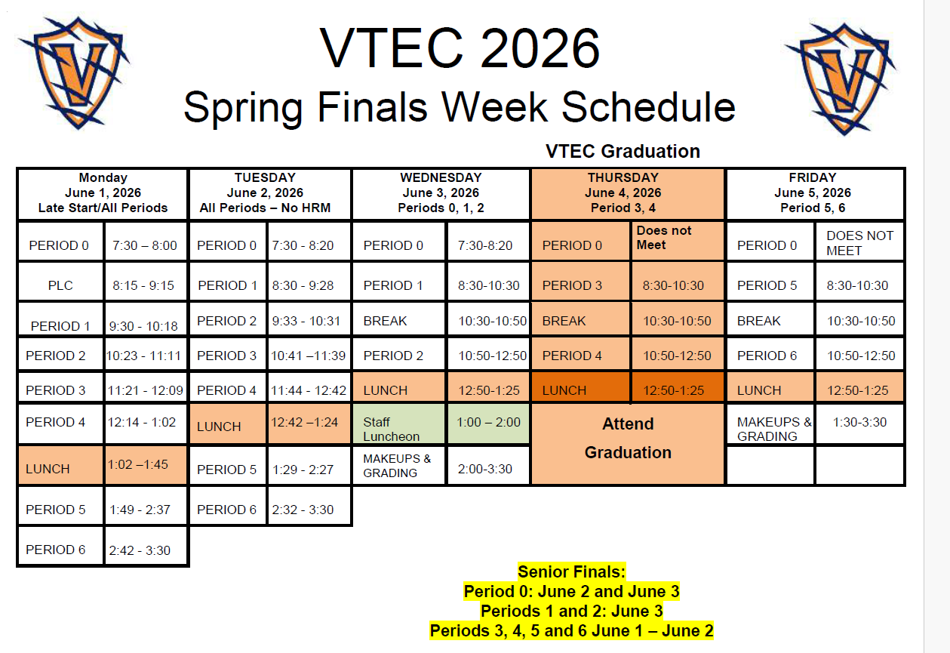

Parents – The 2026/2027 Emergency Card/Registration portal is currently open. Please complete the documentation before the end of the school year. Please reach out to the office if you have any questions. This information is required of ALL parents.

Class of 2026 Graduation – Thursday, June 4th at 4pm at the LJ Williams Theater.

COS Students – Students taking COS courses, your textbook reimbursement forms are due to the office by June 5th. You need the textbook reimbursement form, copy of your COS grade and a copy of your receipt. See the office if you have any questions.

2025-2026 FFA Schedule of Events is attached.

Students – If your third party food delivery is delivered after the lunch bell rings – you may pick up your food after school. Food will not be available during class time.

Parents/Students - If your student has an unscheduled/COS period and chooses to remain on campus they must report to Room 4 and stay in the room for the duration of the period. Due to safety, staff must know where students are at all times while on campus. Students who have an unscheduled/COS class during their schedule may leave campus but must check out through the front office. Thank you for your understanding.

Students – Friendly reminder that the front parking lot is for staff and visitors only. There is student parking in the lot north of the office. Thank you –

Students – If you have 3 tardies, you will lose off campus lunch privileges for 3 days.
If you have 6 or more tardies, you will lose off campus lunch privileges for 5 days and have lunch detention in Room 4 for the first 20 minutes of lunch.
Students – If you have any of the following – you will NOT be able to leave campus for lunch:
- Two or more F’s
- One F and any D’s
- 3+ D’s

If you are late coming back from lunch, you will lose off-campus privileges for 5 days.

