VISALIA TECHNICAL EARLY COLLEGE
HOME OF THE WOLVERINES



Daily Bulletin - Volume 14; Issue 180
FRIDAY, JUNE 5, 2026

FINALS Bell Schedule – June 1st-5th
See Bell Schedule Below

FINALS Bell Schedule –

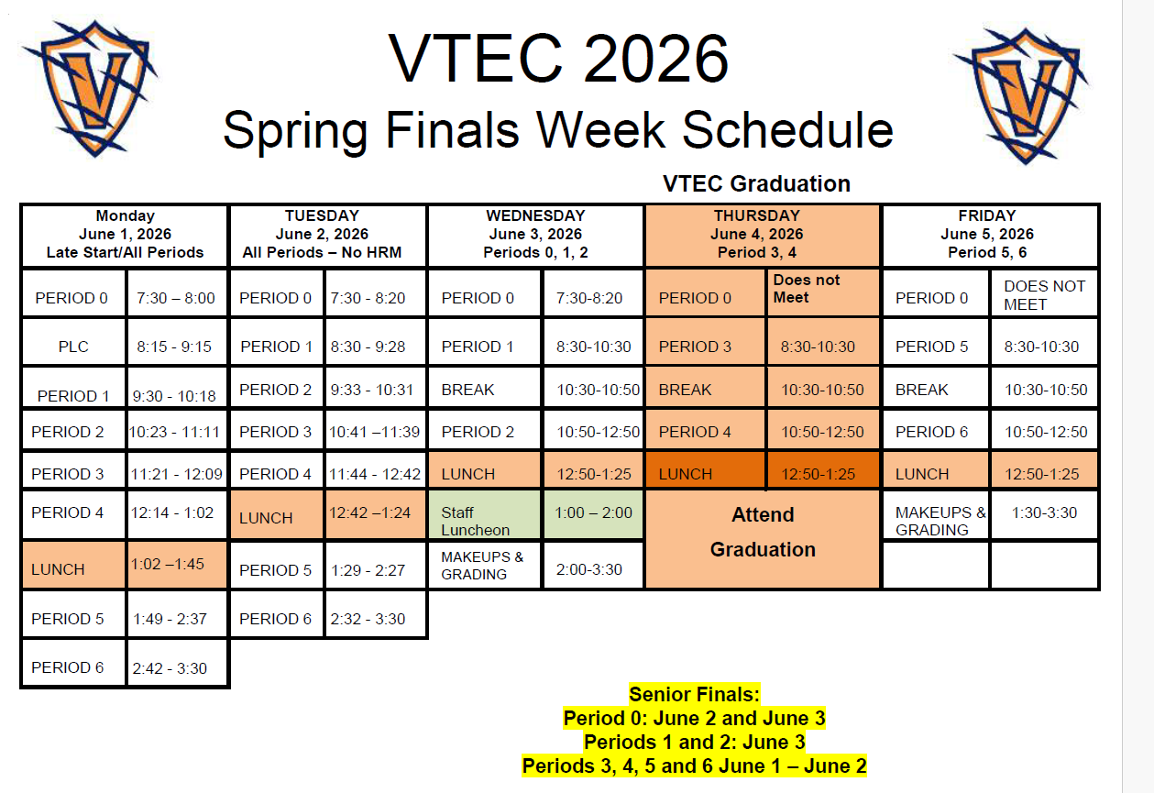

Bell Schedule – Friday, June 5th

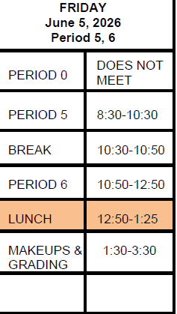

Seniors -If you received a Scholarship from the VTEC Scholarship Foundation, read the instructions carefully!! To receive your scholarship check you must submit certain information on June 8th or June 9th. See Mrs. Lalanne if you have any questions.

Parents – The 2026/2027 Emergency Card/Registration portal is currently open. Please complete the documentation before the end of the school year. Please reach out to the office if you have any questions. This information is required of ALL parents.

COS Students – Students taking COS courses, your textbook reimbursement forms are due to the office by June 5th. You need the textbook reimbursement form, copy of your COS grade and a copy of your receipt. See the office if you have any questions.

Students – If your third party food delivery is delivered after the lunch bell rings – you may pick up your food after school. Food will not be available during class time.

Students – Friendly reminder that the front parking lot is for staff and visitors only. There is student parking in the lot north of the office. Thank you –

